***New Employees:*** All new employees requesting access to KEES will need to complete the KEES End User Security Agreement.

These instructions can be found in the KEES User Manual in the section: **Request User Access**

Security Agreement can be found in the KEES User Manual under: **Other Helpful Information and Passwords**

This document must be filled out electronically, printed, signed and all three pages provided to the individual’s supervisor with a copy of their Training Transcript verifying the individual has completed the following trainings.

The required trainings are completed through the DCF Training Center

* Information Security Awareness (Course ID #SDOPSE0101) or Information Security Awareness Review (Course ID #SDOPSE0102)

**Note:** This training must have been completed within the last year. A request submitted with the completion date older than a year will be denied.

* Security Awareness Training for Information provided by the U.S. Social Security Administration (Course ID# KEOPSE0101)
* HIPAA Training Courses:
  + HIPAA Awareness (Course ID# ODHRPP0101)
  + HIPAA Core (Course ID# ODHRPP0102)
  + HIPAA More (Course ID# ODHRPP0103)

**Note:** All training verification documents must include the name of the employee, name of the course, and a date that can be associated with the training. Hand-written entries or partial printing of a transcript will be rejected. A request for KEES access may not be submitted in OIM until the KEES Submitter has received all documentation

Supervisor or designated person will provide the completed documents to their Regional KEES Submitter along with the following Employee Information:

* First Name, Middle initial, Last Name
* Display name (if different from their first name)
* Email
* Phone number
* Organization
* Worker ID (if required)
* Job function
* Supervisor Name
* Supervisor Email
* KEES Security Group

A list of the KEES Regional Submitters can be found by going to the **Request User Access** section in the KEES User Manual or through the **KEES Security Access** section in the KEES Repository.

Employees Security Access will be determined by their position within the agency.

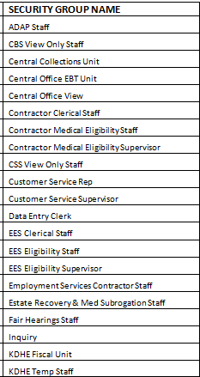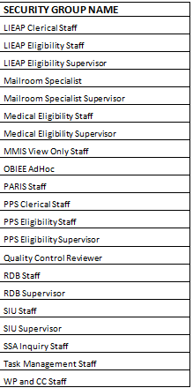

The Worker ID number in KEES is made up of 5 sets of two characters for a total of 10 characters, each two character code represents a value of the following five areas:

Region

Office Location

Office Type

Unit Type

Position Number

DCF Example based on EES Administration: DC3003E1A1

DC = Region

30 = Location

03 = Office Type

E1 = Unit Type

A1 = Position Number

The Worker ID Code Table can be found in the KEES User Manual under the **Worker ID Management** section or in the KEES Repository under **Other Helpful Information.**

To determine if an employee has a worker number assigned, take the following action in KEES:

* From the home page select **Admin Tools** from the Global Navigation bar, this takes you to the Staff Search Page

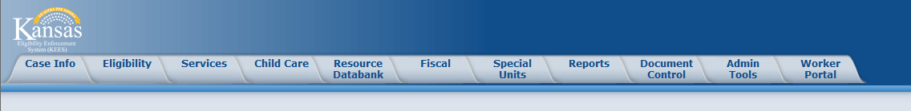

* 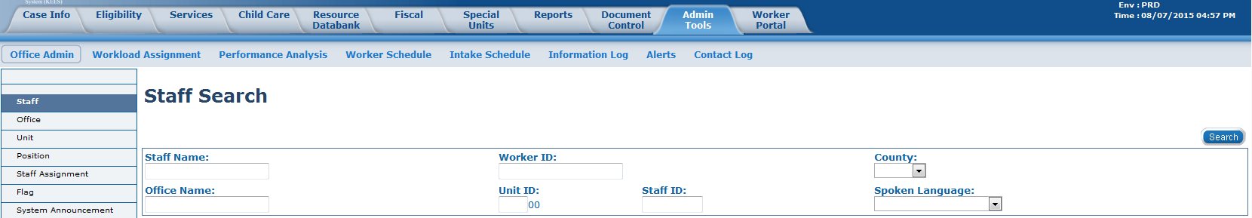Select **Staff** from Task Navigation

* Enter a Search Criteria
  + Search for an individual by entering their name
  + Search for an existing worker ID by entering the Worker ID
  + A search can also be completed by Office

Once it has been determined that a user does not have a worker ID number, the regional designee will assign an ID number based on the employees location and available Unit Number.

* + To determine the available ID numbers in a unit, designee can search using the division ID, unit ID and office location.*** See example below
    - Position numbers are assigned by alpha; there are nine numbers available for each alpha assigned. Once those nine are assigned the next set of ID will start with the next alpha letter.
      * Example: A1 thru A9; B1 thru B9; etc.

The Regional Submitter will use the above information to begin the process of assigning access to KEES by completing information in the OIM (Oracle Identity Manager).

*** This example is based on EES Administration. We are determining the next available Worker ID number for a new user.

From the Admin Tab select Staff Assignment from the Staff Assignment List page

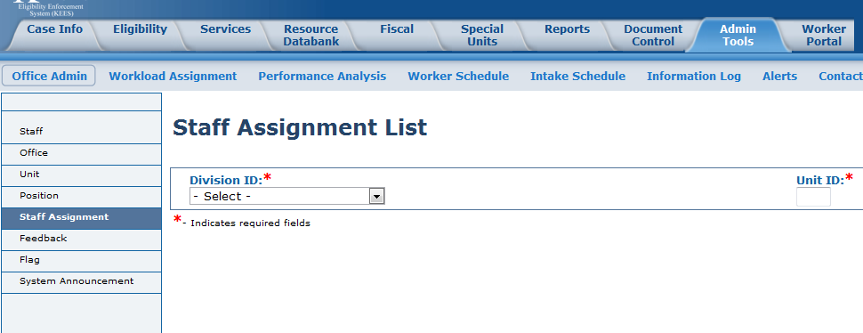

Select EES from the Division ID drop down box and enter unit E1 and click the **GO** button

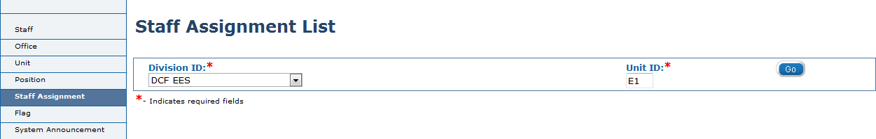

Scroll down to the office location; in our example the next available ID number is DC3003E1C2

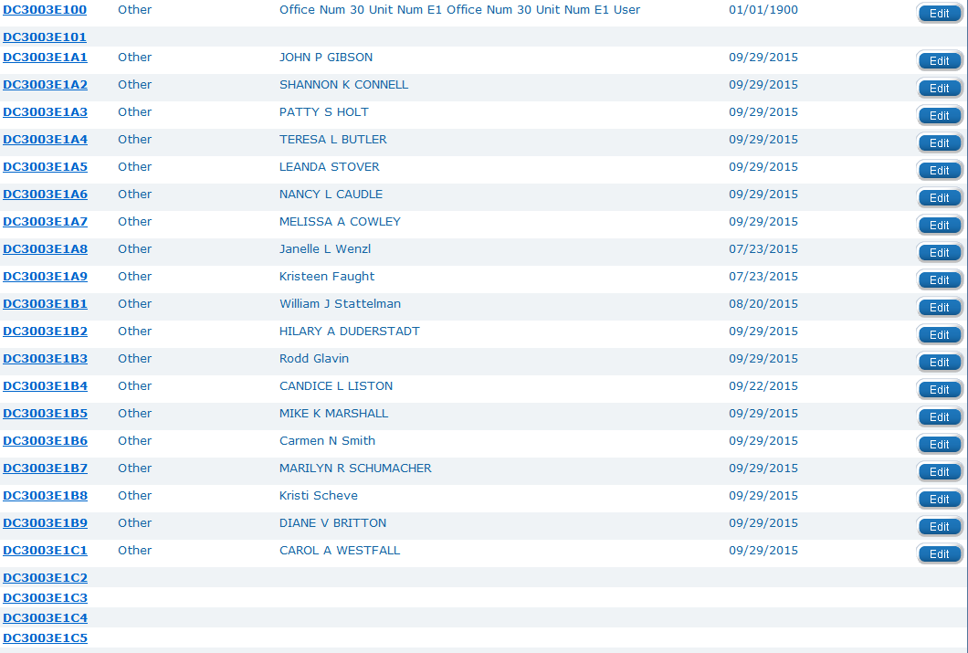

***Employee Changes:***

Name Change

What is needed:

* KEES Change Request Form
  + Use the new name as the User Name on this form
  + Include the KEES User ID in the ID field.
  + Comments section state it is a name change and what the name was before the change.
* New Security Agreement with new legal name.

Region Change

What is needed from Region worker is leaving:

* KEES Change Request Form
  + Check the “Disable all Access” box
* End date worker ID in KEES

What is needed from the Region worker moved to:

* New Security Agreement
* Copy of Transcript with an acceptable training date that is within one year of the Region/Location change.
* KEES Change Request Form
  + Comment section: User Transferred – please Enable with new details
* Make new Worker ID change

Office Change (Same Region)

What is needed from Office worker is leaving:

* KEES Change Request Form
  + Check the “Disable all Access” box
* End date worker ID in KEES

What is needed from the Office worker moved to:

* New Security Agreement
* Copy of Transcript with an acceptable training date that is within one year of the Office/Location change.
* KEES Change Request Form
  + Comment section: User Transferred – please Enable with new details
* Make new Worker ID change

Supervisor Change (Same Department/Division i.e. EES to EES)

What is needed:

* Email [ksc@kees.ks.gov](mailto:ksc@kees.ks.gov) the following -
  + New supervisor’s name and email address
  + User’s full name and email address
* Old supervisor – – end date worker id
* New supervisor – set up new worker id

Position Change with access change (i.e. support staff to eligibility staff)

What is needed:

* KEES Change Request Form
  + On page 2 check all security groups needed for the worker
  + In comments section: clarify that there was a position change
* Old supervisor – end date worker id
* New supervisor – set up new worker id

Department Change

* Same as Position Change

Unit Change (i.e. from EES to PPS)

* Same as Position Change

Security Level Change

* Same as Position Change

Worker Leaves the Agency:

What is needed:

* KEES Change Request Form
  + Mark the “Delete all Access” box.
  + Provide the workers User Id (this helps verify they are deleting the correct worker)
  + If User ID is not known provide the User Name and email address, as it appears in KEES.

How tell if a worker is disabled:

* Supervisor can look this up in KEES -
  + Admin Tools
  + Staff (enter workers name)
  + Search
  + Click on Staff Name
  + Status code will be either Active – FT or Inactive
    - Inactive equates to Disabled in OIM

Worker is Disabled in OIM/Inactive in KEES:

* Submit a KEES Change Request Form requesting Enable access.

Is Worker ID required on new user request forms?

* No it is not required, but it is best practice to do so. If it isn’t provided, then the worker would need to inform the supervisor when they received access so it can be created in order for the worker to work in KEES.